What can you donate?

Changing
- New Packets of Nappies
- Wipes and cream
- Baby bath, wash, shampoo
- Changing Mats / Bags
- New Toiletries
Feeding
- New Bottles
- Manual Breast Pumps
- New Nursing Pads
- Water / steam sterilisers
Equipment
- High Chairs (plastic / metal)
- Travel Systems
- Buggies and Strollers
- Prams and Pushchairs
- Cots (no drop sides)
- Moses Baskets / stands
- Bouncy Chairs
- Play mats/ gyms
Clothing: Premature to 6 months
- Vests
- Bodysuits
- Snowsuits / coats
- Sleeping bags
- Outfits
Accessories
- Cosy Toes
- Rain Covers
- Blankets, sheets, towels
- Baby Carriers
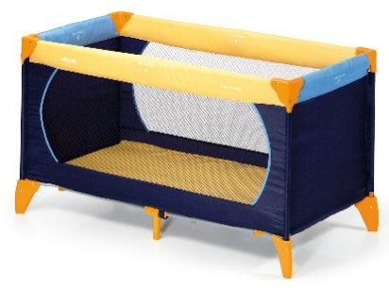
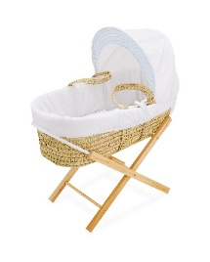

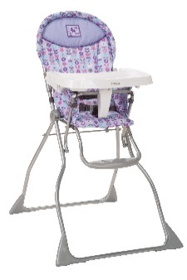
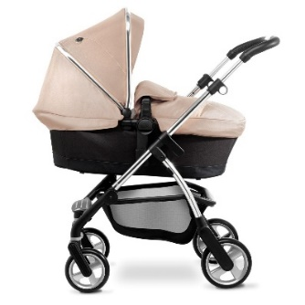

Please ensure all equipment is clean, complete and in good working order.
Clothes should be sorted into appropriate ages, clean and stain free.
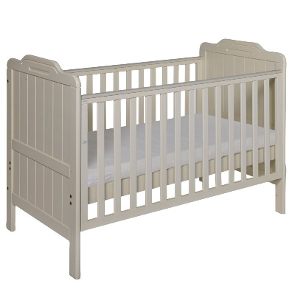

We would ask that all items of equipment are less than 8 years old and comply with current Safety Regulations.
We are unable to accept toys, maternity clothing, books, baby walkers, cot bumpers, cots with drop sides and electrical items.

What happens to your donations?

Thank you for your donations!

We offer support to those for whom a pregnancy is causing financial difficulties. We do this by providing a ‘basket’ of basic supplies and good quality baby clothes as well as loaning out items of equipment such as pushchairs, cots and high chairs etc. free of charge.
For items we are unable to use we reserve the right to:
- Donate to another organisation or Charity
- Sell, with the proceeds being used for the work of Love For The Family
- Send for recycling or disposal

If you are able to supply any instruction manuals for your donated items, or items that might be donated, they would be gratefully received.

Thank you again
Jane

On Behalf of Love For The Family

